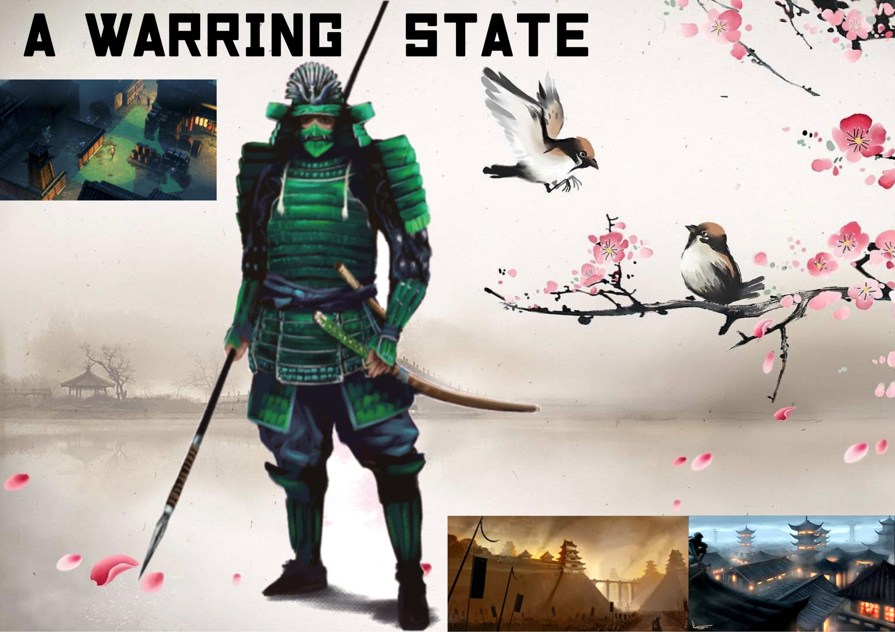

**Internal Goals**

* Make the players feel the inner conflicts of the character (questioning whether they are fighting for a right cause)
* Give the player a feeling of control while not making the level “predictable”